According to Real Estate Information Systems, almost 60% of homes in the U.S. are purchased by people between the ages of 28 & 45, which is within the age group most likely to be expecting access to instant information.
Today’s successful real estate agents are using their tech-obsessed consumer’s lifestyle to their benefit by sharing information directly to the seller or buyer through a mobile device. TITLE COMPANY NAME is here to help, with ready2close!
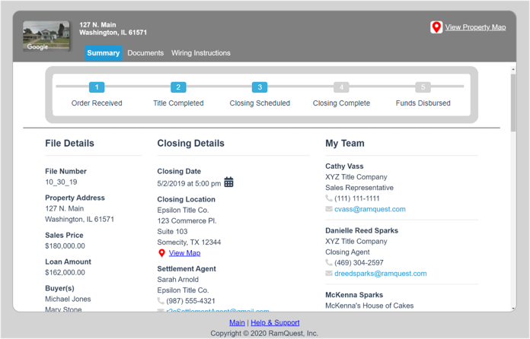
With ready2close, you can see at-a-glance order progress based on major closing milestones. And, buyers and sellers can receive email and/or text updates as these milestones are reached.

You’ll also see file details, closing information and contacts - with mobile-friendly, clickable links – while ensuring information security with role-specific views!

Plus, if a pre-closing document needs a signature, it’s quick and easy to eSign right here!

ready2close is our mobile-friendly closing tool that give you unprecedented access to critical closing information!

With ready2close, you’ll have visibility and access to all your files on one screen, while your Buyers & Sellers will see just their property. This tool also lets you view the property address and Google Map image of the home and a quick click instantly delivers driving directions.

With ready2close, documents on the file can be shared for view, download or to act upon.

Buyers and sellers can also securely upload necessary documents and access secure wiring instructions.

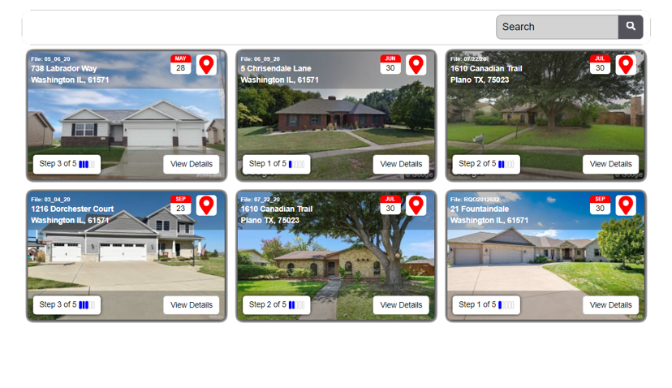

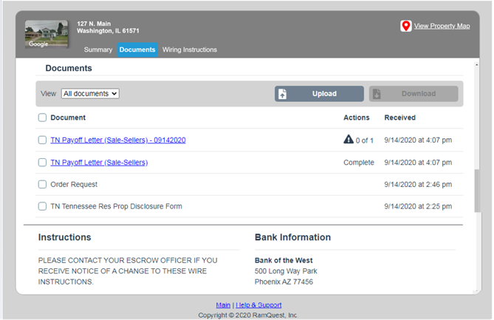

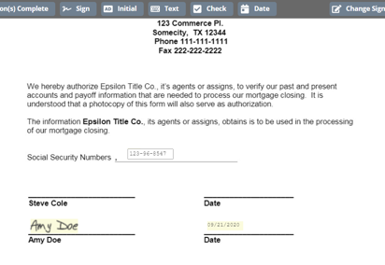

Learn how you can get started with ready2close!

